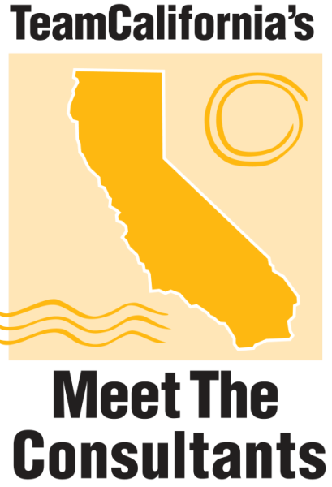

2017 Sponsorship Opportunities

Regional Host Sponsor:

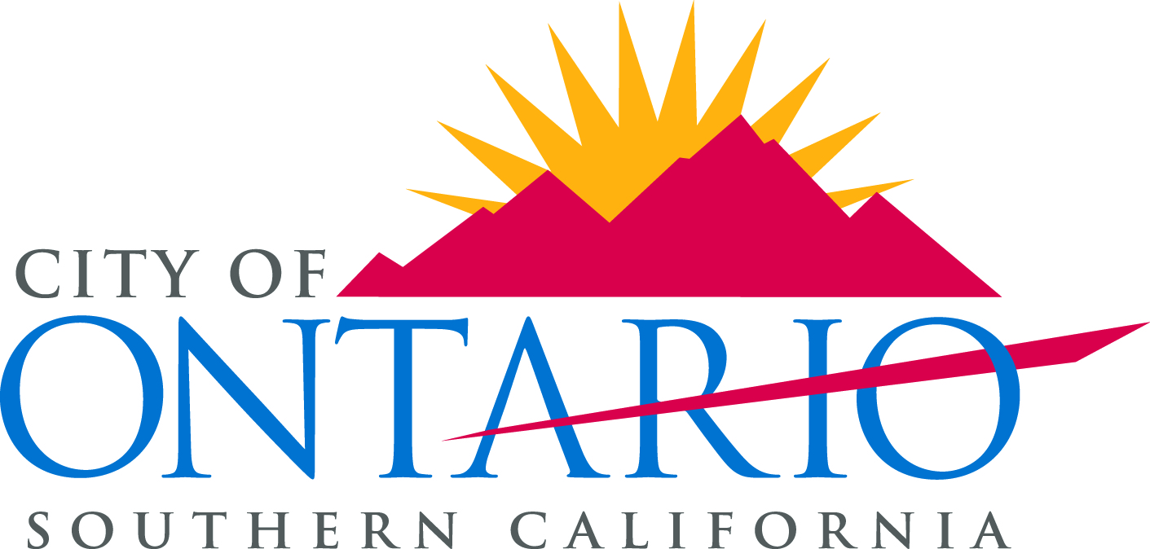

www.ontarioca.gov

Ontario, CA
APRIL 26 – 27, 2017
teamca.org
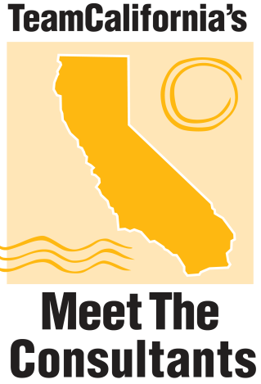

Forum Program Sponsorship
$6,000
1 Available
______________________________________________________________________
Each year, TeamCalifornia’s Meet the Consultants Forum convenes in a different area of California focusing on the diversity of the state. A professional Forum Program is created for the consultants and attendees to be used as a guide during the forum to follow along with the presentations and discussions. The Forum Program is also used by the consultants and attendees as a take away for business networking and future project development. This is a significant information piece which includes all agenda items, contact information for all consultants and site selectors, as well as their presentations and detailed information on the Host Area. As the Official Forum Program sponsor, recognition and the following additional benefits are included:

Benefits
- Logo Placement: Your organization's information on display at the Sponsors Only Table during the reception and throughout the Forum.
- Banner Placement: A banner highlighting your organization will be displayed in the main meeting rooms and during all sponsored events.
- Organizational Profile: You will receive your organization's name and logo on the front of the Official Forum Program, as well as a full page advertisement and profile in the Forum Program.
- Recognition: Recognition of your organization at the event welcoming attendees and throughout the forum. This piece will be used every day of the Forum.
- Registration Bag Insert: One item of your choice placed in registration bag.
- Full Conference Registration: Two conference registrations are included.
- Registration Allowance: You may purchase up to 2 additional registrations.

Site Selection Round Table Discussion Sponsorship
$6,000
1 Available

Each site selector will participate in small round table discussions with attendees joining each of their tables to discuss the most pressing economic development topics. These round table discussions result in an exchange of current information and viewpoints. With this sponsorship, you will host the roundtable activities; you will be given a choice of which consultant to start your discussion. You will also be given the opportunity to be the moderator and assist during the table transitions. Advance preparation with TeamCalifornia will be coordinated with you. Forum attendees will transition between round tables and discuss current industry practices prevalent to the host region and California. As the Site Selection Round Table Discussion sponsor, recognition and the following additional benefits are included:
Benefits:
- Logo Placement: Your organization's information on display at the Sponsors Only Table during the reception and throughout the Forum.
- Banner Placement: A banner highlighting your organization will be displayed in the main meeting rooms and during all sponsored events.
- Organizational Profile: You will receive a full page advertisement or profile in the Forum Program.
- Recognition: Recognition of your organization at the event welcoming attendees and table top recognition at each of the individual tables.
- Registration Bag Insert: One item of your choice placed in registration bags.
- Full Conference Registration: Two conference registrations are included.
- Registration Allowance: You may purchase up to 2 additional registrations.
______________________________________________________________________

2017 Sustainable Utility Strategic Sponsorship
$6,000
1 Available SOLD

Each year, TeamCalifornia’s Meet the Consultants Forum convenes in a different area of California focusing on the diversity of the state. The professional Forum connects attendees directly with decision makers, corporate real estate executives and property developers. The Sustainable Utility Sponsorship is set aside to recognize the utility in California most focused in the region and committed to sustainable utility service.
Your sponsorship opportunity includes:
- Private presentation meeting with site selectors/industry decision makers
- Company name/logo on TeamCalifornia Forum website
- Investor profile – 2 page spread in the Forum Program and on the website
- Distinguished Sponsor Acknowledgement at Forum Events
- VIP Seating with Consultants
- Exhibit Table within the Sponsor Only Recognition Area
- Conference and Consultants Complete Mailing List
- Business Information Item in Attendee Registration Bags – 100 attendees
- Welcome gift to Consultants upon arrival – your decision
- Acknowledgement on all Event Signage
- Full MTC Forum Registrations for four attendees
- Post Forum Acknowledgement
- Forum Website Recognition
- Invitations to the Consultant Dinner and Reception.
_____________________________________________________________________

Annual Forum Dinner Event Sponsorship
$5,000
1 Available - SOLD

The Annual Forum Dinner Event will be held on the arrival and opening night of MTC 2017 with sponsor attendees, consultants and guests. This private event will include a relaxing network focused dinner to connect on a more intimate level with the site consultants. This is a terrific private sponsorship which allows the sponsor to present and gift the VIP’s something from their area. Welcome address and event activity presentation will be coordinated for you to announce. Reserved seating with the site selectors and corporate real estate executives will be handled for this sponsor and their guests to the dinner. As the Annual Forum Dinner Event sponsor recognition and the following additional benefits are included:
Benefits:
- Logo Placement: Your organization's information on display at the Sponsors Only Table during the reception and throughout the Forum. Your organization will also have signage at the Annual Forum Dinner Event and be invited to speak at the podium with introductions and evening events.
- Banner Placement: A banner highlighting your organization will be displayed in the main meeting rooms and during all sponsored events.
- Organizational Profile: You will receive a full page advertisement and a company profile in the Forum Program and on our website.
- Recognition: Recognition of your organization will be at the welcome event for all attendees. Table top recognition at each of the dinner tables will highlight your organization and if desired you may offer the consultants a gift token. You will also receive VIP seating for yourself and your registered attendees during the Annual Dinner Event.
- Registration Bag Insert: One item of your choice placed in registration bags.
- Full Conference Registration: Two conference registrations are included.
- Registration Allowance: You may purchase up to 2 additional registrations.

Site Selector Host Sponsorship
$3,000
5 3 Available

Hosting a Site Selector includes a one on one breakfast meeting with your Site Selector. With this sponsorship, you are invited to attend the dinner event with the Regional Host Sponsor the night before. As a Site Selector Host Sponsor, you will be invited to pick up the consultant from the airport and deliver them to their hotel in preparation for the evening events if you are available and want to do so. If not, transportation will be arranged for the Consultant. Recognition at the Forum and the following additional benefits are included:
Benefits:
- Logo Placement: Your organization's information on display at the Sponsors Only Table during the reception and throughout the Forum.
- Banner Placement: A banner highlighting your organization will be displayed in the main meeting rooms and during the sponsored event. You will also be given the itinerary of the consultant and have ability to coordinate ahead of time if mass transit from a distant airport hasn’t already been arranged. You will receive podium recognition as the consultants sponsor, introduced by the Moderator at the forum and introduce them when they present (A script will be provided).
- Organizational Profile: You will receive a full page advertisement or profile in the Forum Program and on our website.
- Recognition: Your organization's name on your Site Selector's Name Plaque as their host and introduction of the Consultant.
- Registration Bag Insert: One item of your choice placed in registration bag.
- Full Conference Registration: One conference registration is included.
- Registration Allowance: You may purchase up to 2 additional registrations.

Networking Breaks and Wi-Fi Station Sponsorship
$2,500
1 Available

The sponsor of the Networking Breaks and Wi-Fi Stations will receive an introduction from the podium at the beginning of the Forum and this sponsor will announce each networking break and reconvene us after each break. The networking break is intended to connect attendees informally with the consultants and other attendees. Your promotional materials as the Sponsor table. Your logo and contact information will be located on the Wi-Fi stations and on break table displays for attendees. As the Networking Break and Wi-Fi Station sponsor, recognition and these following additional benefits are included:

Benefits:
- Logo Placement: Your organization's information on display at the Sponsors Only Table during the reception and throughout the Forum.
- Banner Placement: A banner highlighting your organization will be displayed in the main meeting rooms and during the sponsored events.
- Organizational Profile: You will receive a half page advertisement or profile in the Forum Program and on our website.
- Recognition: Recognition of your organization at the event welcoming attendees and an introduction from the podium at the beginning and ending of each break and at each Wi-Fi Station.
- Registration Bag Insert: One item of your choice placed in registration bags.
- Full Conference Registration: One conference registration is included.
- Registration Allowance: You may purchase up to 2 additional registrations.

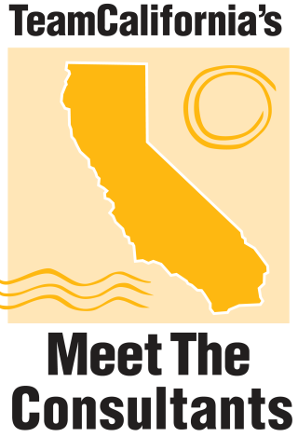

Welcome Reception Sponsorship
$2,500
2 Available

Sponsorship of the Welcome Reception includes signage during the reception at the stations set up to serve the guests and you will be involved in welcoming the attendees from the Welcome podium. The welcome reception is held to bring all forum attendees together for a relaxing, networking opportunity prior to the big kick off event the next morning. The reception also will showcase wonderful foods from California’s growers and highlight your area. You will have access to greet all attendees, consultants and guests as they arrive. You will also be introduced to the consultants prior to the reception in the green room. As the Welcome Reception sponsor, recognition and the following additional benefits are included:
Benefits:
- Logo Placement: Your organization's information on display at the Sponsors Only Table during the reception and throughout the Forum. You will have signage at the reception as well as at the reception stations set up to highlight your areas and regions. There will also be station signage of your area and highlighted at the food areas.
- Banner Placement: A banner highlighting your organization will be displayed in the main meeting rooms and during the sponsored event.
- Organizational Profile: You will receive a half page advertisement or profile in the Forum Program and on our website.
- Recognition: Recognition of your organization during the Forum.
- Registration Bag Insert: One item of your choice placed in registration bags.
- Full Conference Registration: A 50% discount on 1 conference registration.
- Registration Allowance: You may purchase up to 2 additional registrations.

Luncheon Sponsorship
$2,500
3 Available

The purpose of the Hosted Forum Luncheon is to provide additional networking opportunities for consultants and attendees. As a luncheon sponsor you will receive VIP seating with the consultant of your choice and podium recognition for your hosted table as well as on all the luncheon table tops. You will be given podium time to announce your business and affiliation. As one of the Luncheon sponsors, recognition and the following additional benefits are included:

Benefits:
- Logo Placement: Your organization's information on display at the Sponsors Only Table during the reception and throughout the Forum.
- Banner Placement: A banner highlighting your organization will be displayed in the main meeting rooms and during the sponsored event.
- Organizational Profile: You will receive a half page advertisement or profile in the Forum Program and on our website.
- Recognition: Recognition of your organization will be at the welcome event for all attendees. This sponsorship also includes introduction from the podium and selection of a consultant to be your guest at your hosted table.
- Registration Bag Insert: One item of your choice placed in registration bags.
- Full Conference Registration: A 50% discount on 1 conference registration.
- Registration Allowance: You may purchase 3 additional registrations and invite 3 outside guests to register for the luncheon only – separate fee for lunch only.

Registration Bags Sponsorship
$2,000
1 Available

Sponsorship of the Forum Registration Bags is a great way to give your organization recognition throughout the entire event and to all forum attendees. These welcome bags are always a needed conference tool. The registration bags are given to each attendee upon arrival with their materials, Official Forum Program and any handouts to be used during the Forum. You can provide the registration bags with your custom logo or we will create them and discuss the design with you. You are also allowed to put giveaways from your area in the bag as gifts for attendees as well as materials you would like the site selectors to have from you. As the Registration Bag sponsor, recognition and the following additional benefits are included:

Benefits:
- Logo Placement: Your organization's information on display at the Sponsors Only Table during the reception and throughout the Forum.
- Banner Placement: A banner highlighting your organization will be displayed in the main meeting rooms and during the sponsored event.
- Organizational Profile: You will receive a half page advertisement or profile in the Forum Program.
- Recognition: Recognition of your organization at the registration desk - your logo prominently displayed. You are able to include a promotional piece in the registration bag for attendees. Introduction from the podium on opening day and recognition on-site in the program of events and registration table opened all three days is also included.
- Registration Bag Insert: Items of your choice placed in registration bags.
- Full Conference Registration: A 50% discount on 1 conference registration.
Registration Allowance: You may purchase up to 2 additional registrations

Private Transport Sponsorship
$3,000
1 Available - SOLD

Hosting a Site Selector private transport is using TEAMCA vehicles to get site selectors and Corporate Real Estate Individuals to and from private events and the tour of High Speed Rail. We utilize a board member familiar with TeamCalifornia and the MTC Program to be able to welcome the site selectors and make them feel welcome. With this sponsorship, you are invited to attend the dinner event with the Regional Host Sponsor as well as the private reception. Recognition at the Forum, on the Forum Banners and printed materials and the following additional benefits are included:
Benefits:
- Logo Placement: Your organization's information on display at the Sponsors Only Table during the reception and throughout the Forum.
- Banner Placement: A banner highlighting your organization will be displayed in the main meeting rooms and during the sponsored event. You will also be given the itinerary of the consultant and have ability to coordinate ahead of time if mass transit from a distant airport hasn’t already been arranged. You will receive podium recognition as the MTC Transport Sponsor.
- Organizational Profile: You will receive a full page advertisement or profile in the Forum Program and on our website.
- Recognition: Your organization's name on your all printed signs and nametags.
- Registration Bag Insert: One item of your choice placed in registration bag.
- Full Conference Registration: Three full conference registrations included.
- Registration Allowance: You may purchase up to 2 additional registrations.

